**Nutri Track- Your personal Nutrition Assistant Application**

**Ques. In this assignment you will plan your app so that you can start building it for Assignment 2.**

**· Loosely plan a non-relational database: what collections do you envision you will need?**

**Ans.** For an app like Nutri Track, which tracks nutrition and meal information, a non-relational database could be designed to efficiently handle the various types of data involved. Here are some collections (or tables) that might be needed:

Users: Stores user information such as username, email, password (hashed), preferences, etc.

Meals: Contains information about individual meals users have consumed, including the date, time, and any associated metadata.

FoodItems: Stores details about various food items, including their name, nutritional content (e.g., calories, macronutrients), serving size, and any other relevant information.

Favorites: Allows users to store their favourite food items or meals for quick access.

Diary: A collection to store entries made by users in their nutrition diary. Each entry can reference the user, the meal consumed, and any additional information like portion size or comments.

**QUES. · Create mockups/wireframes for all the activities you envision for the app?**

**Ans.** let's create wireframes for the main activities envisioned for the Nutri Track app. Here's a breakdown of the key screens we'll need:

Welcome/Login Screen

Sign Up Screen

Dashboard/Home Screen

Meal Logging Screen

Nutrition Diary Screen

Food Database/Browse Screen

Recipe Creation/Management Screen

Profile Settings Screen

1. First wireframe showing us first page log in or log out.

**Nutri track**

Username

Password

Don’t have any account?

Sign In or Log Out

Grain bowls

Spinach and broccoli

Broiled salmon with herb mustard

Blue barriers smoothie

Avocados with bread

Soya chunks

Tofu with veggies

Meal logging screen

Nutrition Diary

Food Database

Choose the

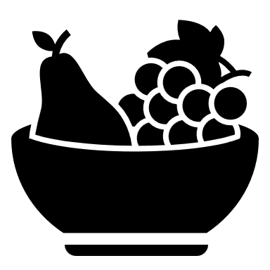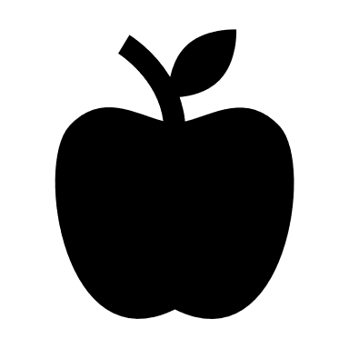

**Home**  **My Recipes Profile** 